**Table of Contents**

* Introduction ………………………………………. 2
* Chapter 1: Total Harmonic Distortion …………… 3
* Chapter 2: Communication ………………………. 5
* Chapter 3: User Control …………………………... 8
* Conclusion ………………………………………... 9
* References ………………………………………… 10

**Introduction**

Since the early 21st century, all home appliances have been powered by electricity, and technology is gradually taking over this industry. And the user's comfort is the primary purpose of technology; a two-hour task may now be completed in two seconds with the push of a button. More specifically, automation, which is an effective approach for reducing personnel, energy consumption, and enhancing the quality and efficiency of any system, will be used in our situation to address an issue that our society is facing.

In recent times, electricity generated from power plants in Lebanon became just adequate for approximately 2 hours per day. To offset this loss, residents were forced to rely on local generators for power. However, the bill was high enough to empty the pockets of Lebanese families, and high-power appliances are main contributors to the cost. As a result, desperate families in Lebanon try to savor every minute of the two hours during which high-powered appliances can serve their purpose.

Our goal is to solve an issue we're having in our everyday lives by installing an Arduino-based automation system to assist us in managing and monitoring home appliances in order to reduce electricity consumption and, in turn, lower our bills. The primary goal of this project is to provide hope in order to alleviate this struggle. Additionally, this system can be upgraded to an IoT system in order to change the house into a more technical or, in other words, more comfortable.

Constructing this system requires identifying the energy source to be monitored using harmonic analysis of the voltage, establishing a connection between the system and the targeted devices using Arduino, adding a relation between the Arduino and the user to form the controller.

1. **Total Harmonic Distortion**

As we know, any periodic function can be written as a Fourier series. Once the Fourier Series coefficients are found (we can find each component using equations given below), the equation of the voltage can be written in this form:

Where 𝑉𝑛 is the nth harmonic at a single frequency voltage, 𝑉1 is the fundamental r.m.s. voltage and 𝑁 is the harmonic order [1]. We intend to use these characteristics to measure THD, or total harmonic distortion defined by the root mean square (r.m.s.) of the harmonic expressed in the percentage of the fundamental component:

Harmonics or harmonic frequencies of a periodic voltage or current are frequency components in the signal that are at integer multiples of the frequency of the main signal. This is the basic outcome that Fourier analysis of a periodic signal shows. Harmonic distortion is the distortion of the signal due to these harmonics [2][3].

After doing numerous tests for both power sources and recording the results in a spreadsheet. For both sources, we'll be able to get an average range. In a way, that's what it should be:

* EDL (Energy of Lebanon) is a state industrial and commercial enterprise in Lebanon that manages 90% of the country's electricity production, transmission, and distribution. Due to improper management, the EDL system is subjected to a variety of distortions, including: TRANSFORMERS LOSSES, UNBALANCED NEUTRAL CURRENTS, SKIN EFFECT...
* EDL was compensated by private generators. However, as time went on, they became nearly the sole source of electricity. And, since it is a private sector, prices have gone through the roof with no regulation, to the point where the majority of inhabitants can no longer afford it.

THD from EDL is eventually higher than THD from private generators [4]. And in this way, we may deduce the source of the electricity entering the house, which will aid us in monitoring the situation or tracking the bill.

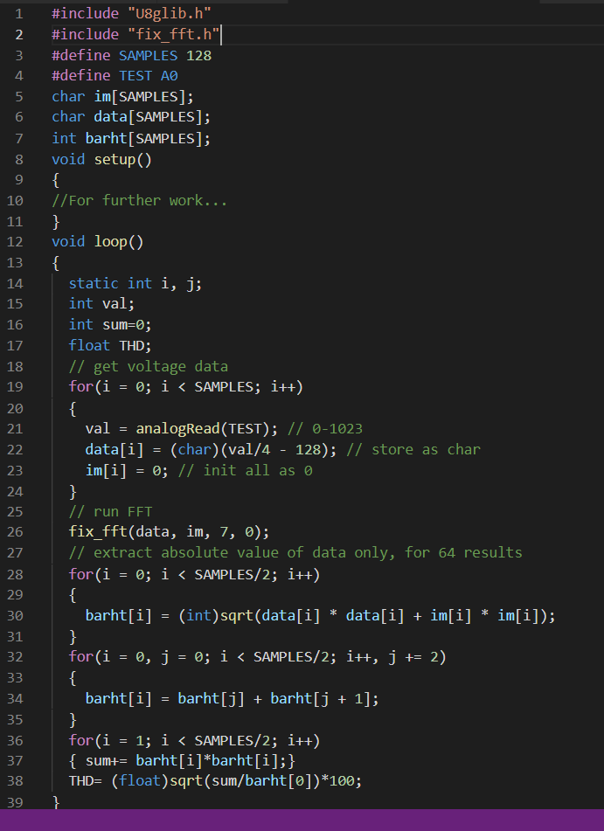Note that the Arduino will receive analog data from any electric source in the house, but Arduino can only hold 5V when the power is 220V. As a result, we should integrate a 220V to 5V inverter system with other justifications that approve Arduino criteria.

This experiment was carried out on an Arduino, and the fft function was used to convert the data

into a Fourier series. Below is a sample of the code we want to use, which will be modified when

further components of the system become available [5].

The results of the identification will be delivered to switches at the end of this operation. A radio connection will be used to communicate between the Arduino and the switches; we will add a transmitter to the Arduino and a receiver to the switches. It will be a simple procedure (that will go further in last chapter Part3 page…) consists of sending a message to the switch (ON/OFF), and the switch will perform their work after reading the message (Part2).

A snippet of transmission code:

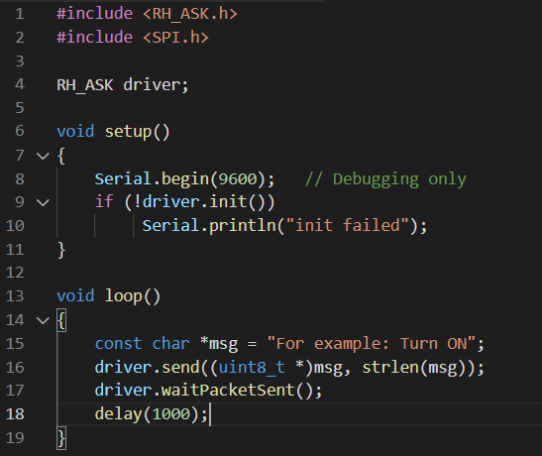

1. **Communication**

The switch will now manage the state of appliances after reading the result from (part1). The switch is made up of two parts: a reader (in this case, a mini-Arduino) and an electric switch.

The mini-Arduino's first function is as a receiver, reading the message or, more simply, the order and adjusting the status of the electric switch to operate the appliance [6].

See the code below.

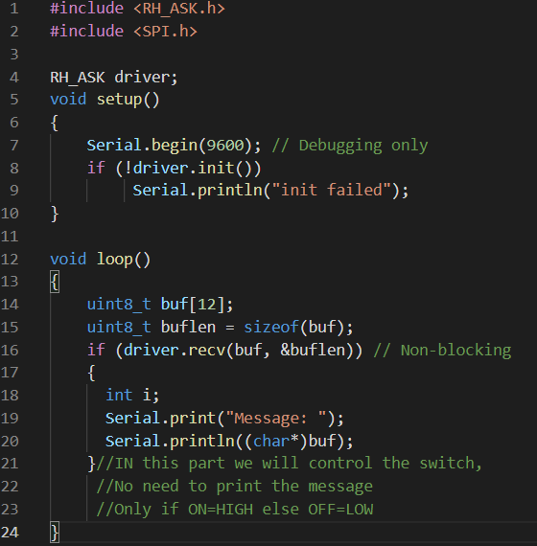As a receiver:

We utilized a transistor and a relay for the electric part. Transistors, as we all know, can be used as switches if they are adjusted in a specific way [7]:

* Transistor switches can control and switch lighting, relays, and even motors.
* The bipolar transistor must be either "fully-OFF" or "fully-ON" when used as a switch.
* Saturation refers to the state of a transistor when it is fully "ON."
* The Cut-off zone refers to transistors that are completely "OFF."
* A modest Base-current controls a much greater Collector load current when the transistor is used as a switch.
* A "Flywheel Diode" is utilized when utilizing transistors to switch inductive loads like relays and solenoids.
* Darlington Transistors are useful for controlling big currents or voltages.

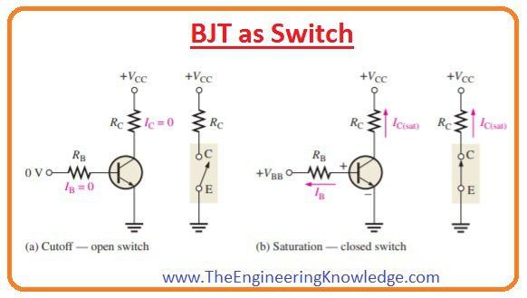

After that, when the relay is added to the system, it will act as a direct connection with the appliance, taking the status to be altered as from the transistor, which also takes the order from the mini-Arduino.

Taking the first two parts together, we will be able to turn on or off the appliance from the main Arduino, which we will also go further in controlling in the final part (Part3) [8].

The switch diagram is as follows:

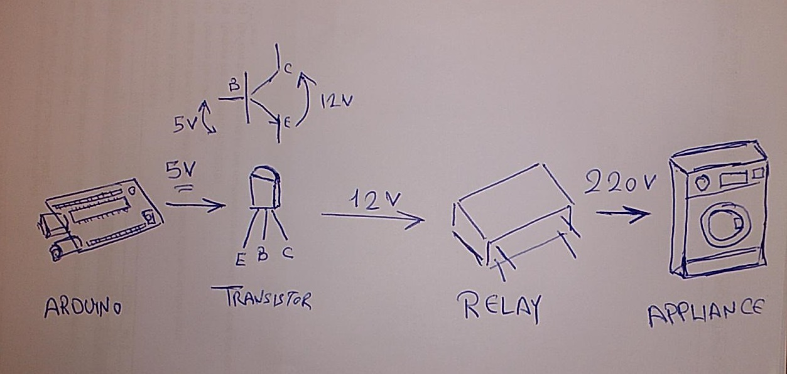

**3- User Control**

This part will be used to take orders from the user. In which case the user should be able to select whether the switch is on or off. In other words, control the appliance. The link between the user and the Arduino is built over wi-fi where the Arduino will set up a web server (a website), where we can add configuration controls, written in html [9].

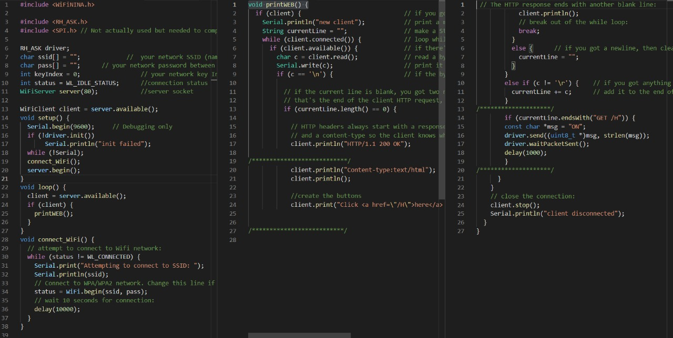

Those three parts combined make up the system.

The Arduino will test the input voltage and do a FFT analysis, in which we compute the THD and compare it to a prior study's average [10]. The identification result will subsequently be presented on the web page (Part 3). In this situation, the user will be allowed to choose the appliance's state (the options can be updated in many ways such as: turn ON whenever the source is EDL). The selected option will be relayed to the appliance's plugged-in switches.

This system may be expanded to handle additional tasks (such as managing all of the house's switches) and add more capabilities, nearly to the point where the house becomes totally automated.

**Conclusion**

Only countries like Lebanon may make advantage of this method. As a result, this is merely a means of reducing consumption, not a solution. It consists mostly of three sections, as previously stated. More power control authority, such as lamps and outlets, can be added. Alternately, construct something resembling a smart home with a little adjustment.

Furthermore, all of the components are inexpensive and widely accessible, and the system is portable and user-friendly, making it simple to use and implement.

By allowing the customer to activate his appliances automatically and remotely, we were able to save both time and money. As a result, we believe that our initiative is a basic, temporary answer to the problem that the majority of Lebanese people face.

It is recommended that this concept be used in more productive ways in future projects, such as irrigation systems, large farms, residential buildings, and more user-dependent gadgets.

**References**

1. Harmonic Meter Design Using Arduino ,[www.sciencepubco.com/index.php/IJET](http://www.sciencepubco.com/index.php/IJET)
2. Power and RMS Values of Fourier Series,<https://studylib.net/doc/18759216/power-and-rms-values-of-fourier-series>
3. Harmonics Sensing Smart Meter Using Arduino, <http://www.ijniet.org/wp-content/uploads/2020/07/s12.pdf>
4. The origin of Harmonics & their effects on a power system, <https://generatorbible.com/blog/what-is-thd/>
5. Fast Fourier transform(FFT) for Arduino, <https://create.arduino.cc/projecthub/abhilashpatel121/easyfft-fast-fourier-transform-fft-for-arduino-9d2677>
6. DIY Arduino RC Receiver for RC models and Arduino projects, <https://howtomechatronics.com/projects/diy-arduino-rc-receiver/>
7. Transistor as a switch, <https://www.electronics-tutorials.ws/transistor/tran_4.html>
8. Drive a 220V/16A Relay with Arduino, <https://www.instructables.com/Simple-and-Straight-Forward-Drive-a-220V-16A-Relay/>
9. Host a Web Server on the Arduino UNO Wifi Rev2, <https://docs.arduino.cc/tutorials/uno-wifi-rev2/uno-wifi-r2-hosting-a-webserver>
10. Plotting the FFT of a voltage signal, <http://benholmes.co.uk/posts/2018/05/plotting-voltage-fft>

Further references:

* Harmonic Distortion in Electrical Systems,<https://www.trane.com/content/dam/Trane/Commercial/global/products-systems/education-training/engineers-newsletters/energy-environment/ADMAPN065EN.pdf>
* Total Harmonic Distortion (THD) and Power Factor Calculation, [https://eepower.com/technical-articles/total-harmonic-distortion-thd-and-power-factor-calculation/#](https://eepower.com/technical-articles/total-harmonic-distortion-thd-and-power-factor-calculation/)
* Easy FFT, <https://www.instructables.com/EasyFFT-Frequency-Transform-for-Arduino/>